**# While Loop**

In C#, *while loop* is used to iterate a part of the program several times. If the number of iteration is not fixed, it is recommended to use while loop than for loop.

**Syntax:**

1. while(condition){
2. //code to be executed
3. }

**Flowchart:**

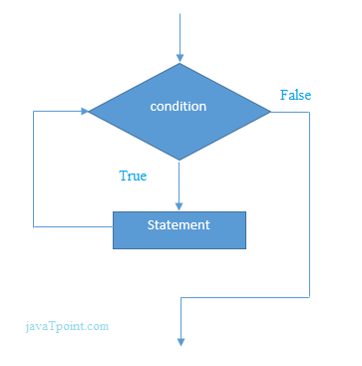

**C# While Loop Example**

Let's see a simple example of while loop to print table of 1.

1. using System;
2. public class WhileExample
3. {
4. public static void Main(string[] args)
5. {
6. int i=1;
7. while(i<=10)
8. {
9. Console.WriteLine(i);
10. i++;
11. }
12. }
13. }

Output:

1

2

3

4

5

6

7

8

9

10

**C# Nested While Loop Example:**

In C#, we can use while loop inside another while loop, it is known as nested while loop. The nested while loop is executed fully when outer loop is executed once.

Let's see a simple example of nested while loop in C# programming language.

1. using System;
2. public class WhileExample
3. {
4. public static void Main(string[] args)
5. {
6. int i=1;
7. while(i<=3)
8. {
9. int j = 1;
10. while (j <= 3)
11. {
12. Console.WriteLine(i+" "+j);
13. j++;
14. }
15. i++;
16. }
17. }
18. }

Output:

1 1

1 2

1 3

2 1

2 2

2 3

3 1

3 2

3 3

**C# Infinitive While Loop Example:**

We can also create infinite while loop by passing *true* as the test condition.

1. using System;
2. public class WhileExample
3. {
4. public static void Main(string[] args)
5. {
6. while(true)
7. {
8. Console.WriteLine("Infinitive While Loop");
9. }
10. }
11. }

Output:

Infinitive While Loop

Infinitive While Loop

Infinitive While Loop

Infinitive While Loop

Infinitive While Loop

ctrl+c